Truman State university

Bicycle Sale

Truman State University will hold a bicycle sale on Thursday, August 29, 2019 at 8:30 a.m. at the Military Storage Building on Florence Street (across from the tennis courts). The bikes will be sold to faculty/staff/students. A Truman ID must be presented to register for a buyer number. Registration will begin at 8:15 a.m. at the Military Storage Building. Buyers will be limited to purchase one bike per person. There are approximately 28 bikes for sale.
Bikes will be sold for $20 (includes tax). Payment must be made by cash or check at the sale site.
Bike will be sold "as is" with no guarantees, refunds, or liability from Truman.

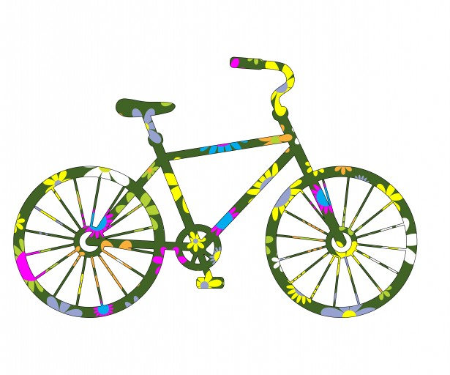

Contact Info:
Barb Newcomer
Truman State University Business Office
105 McClain Hall
Telephone: 660-785-4150
Email: bnewcomer@truman.edu

