**Preface**

Welcome and thank you for taking the initiative to excel in a challenging academic environment and to consider serving your Nation as a Leader in our Army. This Cadet Handbook has been developed by the Cadre and Corps of Cadets of the Truman State University Army ROTC program in order to assist students in achieving a successful transition into college life and the Army ROTC’s Leadership Development Program (LDP).

If you haven't already, please look at our Military Science website and some of the sub-links we've set-up so you can preview our program, the cadre and cadet leadership as well as the paid summer internship and scholarship opportunities available to you at: <http://militaryscience.truman.edu/>

The Cadets of the Bulldog Battalion receive leadership training that is unmatched by any other college course. As Cadets progress through their academic years they receive increasingly more comprehensive instruction in military theory, history, doctrine and organization to compliment the core military science and leadership classes. Leadership roles and responsibilities in the cadet battalion also increase culminating in the senior or MS IV year where the seniors run the program and serve as peer mentors to the underclassmen. This progressive instruction is enhanced by leadership laboratories, a very challenging physical fitness program and summer internships and cadet professional field training to include Airborne, Air Assault, Mountain Warfare, Combat Life Saver and other skills training.

Our Leadership Development Program also offers voluntary extracurricular activities. Rappelling, paintball, canoe and ski trips are always favorites but we also train a Ranger Challenge team that competes in regional and national competitions against other universities in a series of “Military Stakes” type events. The Ranger Challenge Team at Truman has a decade long tradition of excellence placing in the top three schools each of the last ten years. Our Ranger Challenge team training starts early in the fall semester and allows for a more physically challenging atmosphere in order to promote success at the competition. This is our varsity sport and will challenge you to become a better athlete and team member. Additionally, we have a Color Guard ceremonial detail, Howitzer cannon crew and “Recondo” Club that teaches additional tactical military skills to improve our cadets’ leadership skills.

The TSU Army ROTC Cadre consists of experienced US Army Officers and NCOs, all of whom have deployed to Iraq or Afghanistan. These professional instructors are specially selected by the Army to serve at the University and develop the future leaders of our Nation and our Army. You will receive personalized assistance in mapping out your progression as a student and enhancing your personal leadership skills. This invaluable leadership training will serve you well in whichever career field you ultimately choose to pursue. If you decide on a pursuing a career in the Active Duty Army, National Guard or US Army Reserve, by signing up for Military Science classes you will have completed the first steps necessary to receive an ROTC scholarship and ultimate commission as an Army Officer upon graduation.

***-LEADERSHIP EXCELLENCE IS NO ACCIDENT-***

**BULLDOG PRIDE!**

**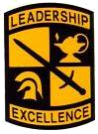 **

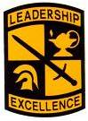**ROTC and U.S. Army Cadet Command (USACC) History**

The Army Reserve Officers' Training Corps (ROTC), as it exists today, began with President Wilson signing the National Defense Act of 1916.  Although military training had been taking place in civilian colleges and universities as early as 1819, the signing of the National Defense Act brought this training under single, federally-controlled entity: The Reserve Officers' Training Corps.

Army ROTC is the largest officer-producing organization within the American military, having commissioned more than half a million second lieutenants since its inception. Women have been an integral part of the Army ROTC since school year 1972-1973.  The first group of females from ROTC was commissioned in school year 1975-1976.  Today, women constitute 20 percent of the Corps of Cadets and more that 15 percent of each commissioning cohort.

In April 1986, the U.S. Army Cadet Command was formed.  With its headquarters at Fort Monroe, Virginia, Cadet Command assumed responsibility for more than 400 senior ROTC units, four regional headquarters, and the Junior ROTC with programs in more than 800 high schools. Cadet Command transformed the ROTC from a decentralized organization turning out a heterogeneous group of junior officers into a centralized command; producing lieutenants of high and uniform quality. An improved command and control apparatus, an intensification and standardization of training, and improvements in leadership assessment and development helped produce this transformation of pre-commissioning preparation.

Today, Army ROTC has a total of 273 programs located at colleges and universities throughout the 50 states, the District of Columbia, Puerto Rico with an enrollment of more than 20,000. It produces approximately 60 percent of the second lieutenants who join the active Army, the Army National Guard and the U.S. Army Reserve.  More than 40 percent of current active duty Army General Officers was commissioned through the ROTC. Of even greater importance is that ROTC trained and educated officers bring a hybrid vigor to our officer corps by drawing on the strength and variety of our social fabric. This reduces the natural tendency of armies to drift into inbred professional separatism. Cadet Command accomplishes this by combining the character building aspects of a diverse, self-disciplined civilian education with tough, centralized leader development training. This process forges a broad-gauged officer who manifests the strength and diversity of the society from which he or she is drawn as well as the quality of strong officer leadership.

**History of Army ROTC at Truman State University**

In 1968, the Department of the Army authorized Truman State University to establish an ROTC program. The program agreement stated that ROTC would be mandatory for all incoming freshmen, replacing the general education requirement of physical education. After completing their freshmen year, continuation of the ROTC program would be optional.

The new program was placed on the academic schedule as of the fall semester SY 1969-1970. More than 600 young men were enrolled in the fall of 1969. On 23 September 1969, the first leadership lab was held. In January 1970, the first female enrolled in the program and in February the rifle range in the basement of Brewer Hall was opened for Truman undergraduate students. On 19 May 1970, the first military banquet was held at the Bonfoey Inn.

During the summer of 1970, 17 Truman State University students attended Advanced Camp at Fort Riley and 25 attended Basic Camp at Fort Knox.

The first commissioning ceremony was held on 27 May 1971. At this time, there were four commissionees. Since that time, more than 550 lieutenants have been commissioned through the Bulldog Battalion. Over one-third still serves in the United States Army, Army National Guard, or Army Reserve.

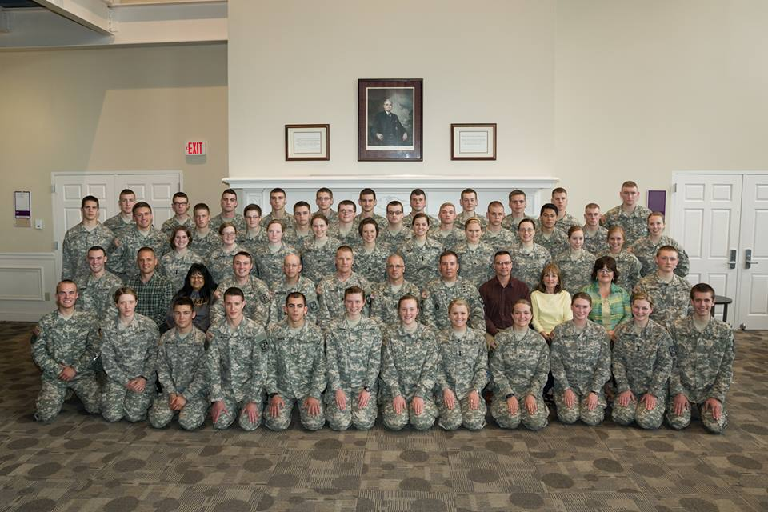

**The Cadet Command (ROTC) Patch**

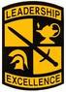

The Cadet Command Shield symbolizes the Army mission of National Defense and is divided into quarters representing the four traditional Military Science Courses comprising the Senior ROTC curriculum.

The Sword signifies courage, gallantry, and self-sacrifice intrinsic to the profession of arms.  The Lamp denotes the pursuit of knowledge, higher learning, and the partnership of Army ROTC with American colleges and universities.

The Greek Helmet is symbolic of the ancient civilization concept of the Warrior Scholar.  The motto "Leadership Excellence" expresses the ultimate responsibility of Army ROTC in the discharge of its moral responsibility to the Nation.

Formal approval was granted by the U.S. Army Institute of Heraldry on 22 August 1986.

**THE CADET CREED**

 I am an ARMY Cadet.

Soon I will take an oath and become an Army Officer committed to DEFENDING the values which make this Nation great.

HONOR is my touchstone.

I understand MISSION first and PEOPLE always.

I am the PAST, the spirit of those WARRIORS who have made the final sacrifice.

I am the PRESENT, the scholar and apprentice soldier enhancing my skills in the science of warfare and the art of leadership.

But above all I am FUTURE, the future WARRIOR LEADER of the United States Army. May God give me the compassion and judgment to lead and the gallantry in battle to WIN.

I WILL DO MY DUTY.

**The Seven Army Values**

**L-D-R-S-H-I-P**

“Our profession’s ethic remains the foundation of trust which the American people place in their military”

**Loyalty**  
Bear true faith and allegiance to the U.S. constitution, the Army, and other soldiers.  
Be loyal to the nation and its heritage. Leaders who demonstrate loyalty:

* Bear true faith and allegiance in the correct order to the Constitution, the Army, and the organization.
* Observe higher headquarters’ priorities.
* Work within the system without manipulating it for personal gain.

**Duty**  
Fulfill your obligations.  
Accept responsibility for your own actions and those entrusted to your care.  
Find opportunities to improve oneself for the good of the group. Leaders who demonstrate devotion to duty:

* Fulfill obligations—professional, legal, and moral.
* Carry out mission requirements.
* Meet professional standards.
* Set the example.
* Comply with policies and directives.
* Continually pursue excellence.

**Respect**  
Rely upon the golden rule – Treat others as you want to be treated.  
How we consider others reflects upon each of us, both personally and as a professional organization. Leaders who demonstrate respect:

* Treat people as they should be treated.
* Create a climate of fairness and equal opportunity.
* Are discreet and tactful when correcting or questioning others.
* Show concern for and make an effort to check on the safety and well-being of others.
* Are courteous.
* Don’t take advantage of positions of authority.

**Selfless Service**  
Put the welfare of the nation, the Army, and your subordinates before your own.  
Selfless service leads to organizational teamwork and encompasses discipline, self-control and faith in the system. Leaders who demonstrate selfless service:

* Put the welfare of the nation, the Army, and subordinates before their own.
* Sustain team morale.
* Share subordinates’ hardships.
* Give credit for success to others and accept responsibility for failure themselves.

**Honor**  
Live up to all the Army values. Leaders who demonstrate honor:

* Live up to Army values.
* Don’t lie, cheat, steal, or tolerate those actions by others.

**Integrity**  
Do what is right, legally and morally.  
Be willing to do what is right even when no one is looking.  
It is our "moral compass" an inner voice. Leaders who demonstrate integrity:

* Do what is right legally and morally.
* Possess high personal moral standards.
* Are honest in word and deed.
* Show consistently good moral judgment and behavior.
* Put doing the right thing ahead of being popular.

**Personal Courage**  
The ability to face fear, danger, or adversity, both physical and moral courage. Leaders who demonstrate personal courage:

* Show physical and moral bravery.
* Take responsibility for decisions and actions.
* Accept responsibility for mistakes and shortcomings.

**Basic Officer’s Leader Course (BOLC) Framework**

**6-14 Weeks of Tng**

**6 Weeks of Tng**

**5 processing days**

Functional

Training

(ABN/Ranger,

Scout Leader)

**Phase II**

**Phase III**



**First Unit**

**Assigned**



**Phase I**

Ft Benning

Ft Bliss

Ft Knox

Ft Sill

SC

MI

QM

OD

FI

AG

TC

MS

FA

AV

AD

IN

AR

EN

MP

CM

The United States Army commissions officers from three primary sources:

1. The Reserve Officers Training Corps (ROTC)
2. The United States Military Academy (USMA)
3. Officer Candidate School (OCS)

Taken together, these three sources represent Phase I of BOLC.

**Army ROTC (BOLC I) at Truman State University**

The Army Reserve Officers' Training Corps (ROTC) at Truman State University is an educational and leadership development program which combines college electives in military science with practical leadership training to prepare men and women to become Army officers. Upon successful completion of the Army ROTC program and graduation from Truman, cadets receive their commissions as Second Lieutenants in the active Army, Army Reserve or Army National Guard.

**BOLC Phase II**

BOLC II consists of technical training in your assigned Army branch (Infantry, Aviation, Signal, Army Nurse, etc.) conducted at your branch’s Officer Basic Course schoolhouse location.

**ROTC Curriculum**

**Military Science and Leadership Courses**

Army ROTC at Truman is divided into a Basic and Advanced Course. The Basic Course equates to Freshman and Sophomore (MS I & II) academic years while the Advanced Course is for academic juniors and seniors (MS III & IV). Cadets can either enter as normal progression cadets and take the 4 year course or as lateral entry cadets taking the 2 year course following the Leader’s Training Course (LTC – outlined below).

**Four-Year Program**

Students take one course and participate in a leadership laboratory each semester. Cadets attend Leadership Development and Assessment Course (LDAC), a five week leadership course conducted at Fort Lewis, Washington during the summer between junior and senior year. Cadets must also complete an approved course or show proficiency in each of the following areas: human behavior, computer literacy, mathematical reasoning, and written communications. Complete the Basic and Advanced courses listed below.

|  |  |
| --- | --- |
| **COURSE** | **CREDITS** |
| **FRESHMAN YEAR** |  |
| **Fall Semester** |  |
| MS 100 Introduction to Military Science I w/ Lab | 1 |
| **Spring Semester** |  |
| MS 101 Introduction to Military Science II w/ Lab | 1 |
| **SOPHOMORE YEAR** |  |
| **Fall Semester** |  |
| MS 200 Perspectives in Leadership I w/ Lab | 2 |
| **Spring Semester** |  |
| MS 201 Perspectives in Leadership II w/ Lab | 3 |
| **JUNIOR YEAR** |  |
| **Fall Semester** |  |
| MS 300 Military Leadership Development w/ Lab | 3 |
| **Spring Semester** |  |
| MS 301 Advanced Leadership Development w/ Lab | 3 |
| MS 302 Advanced Leadership Practicum (LDAC - 5 weeks, summer) | 6 |
| **SENIOR YEAR** |  |
| **Fall Semester** |  |
| MS 400 Seminar: Leadership & Management w/ Lab | 3 |
| **Spring Semester** |  |
| MS 401 Advanced Seminar: Leadership & Management w/ Lab  MS 305: Battle Analysis (1)  Military History Component (3) | 3 |
| **COMMISSIONED** | 26 |

**Two-Year Program**

Truman students who did not take ROTC during their freshmen and sophomore years, and transfer students should attend **Cadet Leader Course** (CLC). The seven weeks during summer will consist of four weeks of tactical training for all cadets. Then some will branch off for three weeks of special training, such as Cultural Understanding and Language Proficiency. LTC is a paid, no obligation, four week Army internship conducted at Fort Knox, Kentucky during the summer between sophomore and junior year. Attendance of the Leader's Training Course satisfies required freshman and sophomore classes (Basic Course requirements). Students attending Leader's Training Course may receive up to seven credit hours towards graduation requirements. Successful completion of Basic Training also satisfies this requirement. Students are required to take on a military science class and Leadership Laboratory each semester. Cadets must attend a five-week course conducted at Fort Knox, Kentucky during the summer between junior and senior year (LDAC). Completion of an approved course or showing proficiency in each of the following areas: human behavior, computer literacy, mathematical reasoning, and written communications are required. Successful completion of at least 54 semester hours is required prior to enrollment. Complete all of the Advanced Courses listed below.

|  |  |
| --- | --- |
| **COURSE** | **CREDITS** |
| Leaders Training Course (4 weeks Summer) | 7 |
| **JUNIOR YEAR** |  |
| **Fall Semester** |  |
| MS 300 Military Leadership Development w/ Lab | 3 |
| **Spring Semester** |  |
| MS 301 Advanced Leadership Development w/ Lab | 3 |
| MS 302 Advanced Leadership Practicum (LDAC - 5 weeks, summer) | 6 |
| **SENIOR YEAR** |  |
| **Fall Semester** |  |
| MS 400 Seminar: Leadership & Management w/ Lab | 3 |
| **Spring Semester** |  |
| MS 401 Advanced Seminar: Leadership & Management w/ Lab  MS 305: Battle Analysis (1)  Military History Component (3) | 3 |
| **COMMISSIONED** | 26 |

**A Written Communication Skills Course** is designed to promote writing effectiveness. Recommended courses: Advanced English Composition, Creative Writing, Business Writing OR Scientific Writing & Languages, Writing for Mass Communicating. Alternate Courses: Linguistics, Logic, other courses with Professor of Military Science’s permission.

**A Human Behavior Course** helps in order to gain knowledge of human and societal development as a basis for understanding of the human aspects of command, military operations and training, and combat and training developments. Recommended courses are: General Psychology, Sociology, Anthropology and Ethics. Alternate courses may be taken with Professor of Military Science’s permission.

**Course Descriptions**

**BASIC COURSE**

**MS 100 Introduction to Military Science I**

**1 Credit Hour**

Provides an overview of the mission and roles of the US Army, the Reserve Officers Training Corps, the National Guard, the Army Reserves, and the Department of Defense in support of the Constitution. Emphasis is also given on developing a personal physical fitness program. This course along with MS101 fulfills the Personal Well-Being as an Essential Skill requirement.

**MS 101 Introduction to Military Science II**

**1 Credit Hour**

Teaches students the principles of war, basic small unit tactics, basic map reading, and treatment of hot and cold weather injuries. Basic leadership principles are also emphasized. This course along with MS100 fulfills the Personal Well-Being as an Essential Skill requirement.

**MS 125 Ranger Challenge** **1 credit hour**

Ranger Challenge is the national ROTC "Varsity" team competition that tests mental and physical endurance and teamwork. Ranger Challenge offers eight weeks of training covering eight separate events. The events are the Army Physical Fitness Test (APFT), orienteering, one-rope bridge, weapon assembly/disassembly, grenade assault course, weapons firing, small unit patrolling, and a 10 kilometer road march. Students will train 14.5 hours per week and four of the eight weekends, in preparation for the final Ranger Challenge competition. This course is only offered during the fall semester.

**MS 200 Perspectives in Leadership I**  **2 credit hours**

Emphasis is on developing leadership skills and self-confidence. Students learn and practice leadership techniques and study communications skills, human behavior, motivation, ethics, counseling, and general principles of organizational and individual leadership. Students also study American Military History from the French and Indian War to the War of 1812.

**MS 201 Perspectives in Leadership II** **3 credit hours**

Emphasis is on the continued practice and refinement of leadership skills. Students also learn effective military writing and speaking. Small unit tactics and American Military History from the War of 1812 to the Mexican-American War are also studied. This course is **WRITING ENHANCED** and counts as one of the two writing enhanced courses that must be taken, as outlined in the [Liberal Studies Program](http://www.truman.edu/pages/106.asp" \t "_top).

**ADVANCED COURSE**

**MS 300 Military Leadership Development** **3 credit hours**

Leadership Practicum in management decision-making and problem solving in small group situations. Emphasis is placed on basic military leadership, tactical and technical skills development. The mandatory labs enable students to apply military skills learned in prior classes and leadership labs in preparation for Advanced Camp. Map reading and military communications practical exercises are also conducted. The military aspects of the Civil War through the Spanish-American War are also studied.

**MS 301 Advanced Leadership Development** **3 credit hours**

Students learn the leader's role in directing and coordination individual and small unit efforts to execute offensive and defensive tactical missions. Tactics, combat support and troop leading procedures are also studied, as well as the American involvement in World War I.

**MS 302 Advanced Leadership Practicum** **(LDAC)  
6 credit hours**

A five-week practical training exercise in a field training environment at a military installation to develop, demonstrate and evaluate leadership capabilities. Required for all cadets prior to being commissioned. Successful completion of the Army Physical Fitness Test (APFT), Land Navigation Course, rifle marksmanship, and leadership performance evaluation is required for practicum credit. Students are paid for this experience.

**MS 303 Special Topics: Leadership Assessment** **3 credit hours**

Designed to determine the viability of using U.S. Army leadership assessment techniques and procedures for use in assessing student leadership on a University-wide basis.

**MS 305 Battle Analysis** **1 credit hour**

Students learn the "Staff Ride" methodology and develop critical thinking, briefing and writing skills used in a formal analysis of a military battle. This course satisfies the mandatory Profession Military Education requirement.

**MS 400 Seminar: Leadership and Management** **3 credit hours**

Advanced leadership skills, counseling, personnel management, command and staff functions, training management, written and oral communications, and military skills are emphasized. The US Army Role in World War II and Korea are also examined. Students also serve as primary leaders within the Bulldog Battalion.

**MS 401 Advanced Seminar: Leadership and Management** **3 credit hours**

The capstone Military Science experience is designed to assist students with the transition to duty in the Active Army, Army Reserve or Army National Guard. Emphasis is placed on professional and personal ethics, personal finance planning, the military logistical system, and Military Law. The US Army involvement in Vietnam, Desert Storm and the future role of the US Army in support of national policy are also studied.

**Professional Military Education**

In order to receive your commission you must complete the following Professional Military Education (PME) requirements in addition to any undergraduate degree requirements Truman State University requires:

* Military Science 305 – Battle Analysis. 1 Credit Historical Staff Ride conducted MS IV year in the spring semester.
* Military History – A 3 credit course that satisfies the US Army Cadet Command’s military history pre-commissioning professional military education requirement IAW TRADOC Reg 350-13 The following Truman courses satisfy this requirement:

o HIST 425 – Civil War and Reconstruction

o HIST 461 – Viet Nam Survey

o HIST 560 – US in WWII

o JINS 369 – Why We Fight

o MS 303 – Theory, History and Doctrine of War

**ROTC Scholarships**

**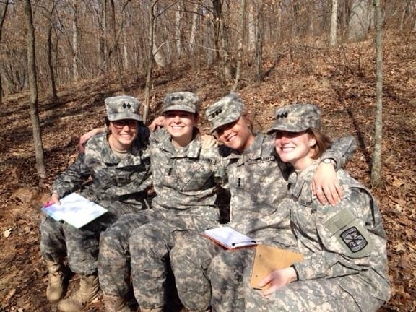 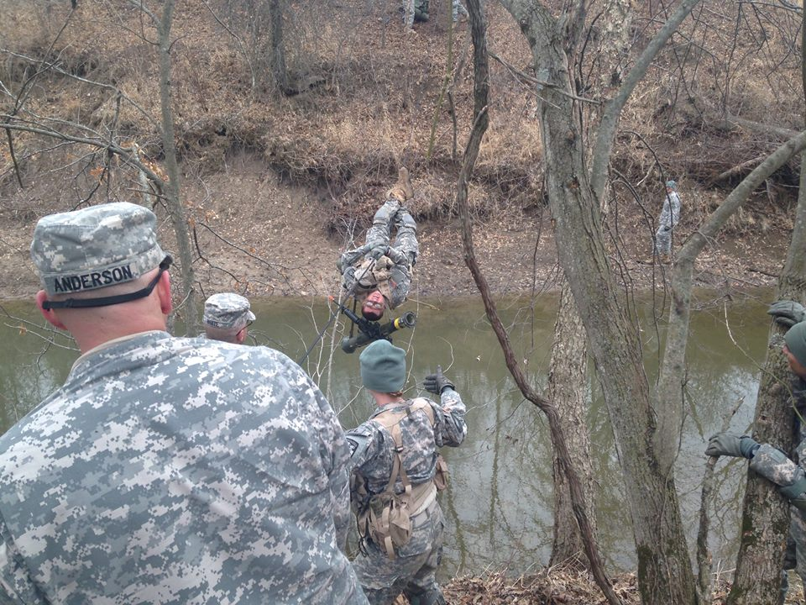**

**Federal Scholarships:**

Army ROTC is the **single largest** source of scholarship money in the United States. Each year, the Army awards millions of dollars in scholarships to thousands of deserving students nationwide. At Truman State University approximately 90% of all students enrolled into the Advanced Course have been awarded scholarships. These scholarships were awarded based on merit, not financial need. Four-, three-, and two-year scholarships are available to qualified students. High school seniors can apply for either a four-year or three-year scholarship. College students can apply for either three-year or two-year scholarship.

**Army ROTC scholarships pay for:**

* Tuition or room & board on or off-campus
* Books - $1200 yearly book allowance
* Most college fees
* Tax-free subsistence allowance of $300 for freshman, $350 for sophomores, $450 for juniors and $500 for seniors per month for up to 10 months a year

**Guaranteed Reserve Forces Duty Scholarship:**

To receive this scholarship, a student must meet all the eligibility requirements listed above and will receive a commission in the Army Reserve or National Guard. The benefits, listed below, are also the same. Winners of these scholarships must participate in the Simultaneous Membership Program (described below).

**Simultaneous Membership Program (SMP).**

The Simultaneous Membership Program is an Officer-training program designed to train officers for the Army Reserve and the National Guard through the ROTC program. An SMP cadet is both a member of the ROTC program and of an Army Reserve or National Guard unit and attends drill with his/her unit. SMP cadets typically shadow platoon leaders in their unit giving them real world insight into the working of an Army Reserve or National Guard platoon. At the same time, SMP cadets attend Military Science classes and participate in ROTC training exercises. SMP cadets receive drill pay as an E5 and the monthly ROTC stipend.

**Additional Incentives Provided by Truman State University:**

* Free room and board for a limited number of scholarship winners with a 25 ACT and 3.25 cumulative GPA
* Academic credit for all Military Science classes
* Offers minor in Military Science
* Satisfies portion of graduation core requirement
* Scholarships and university incentives are awarded based on several criteria

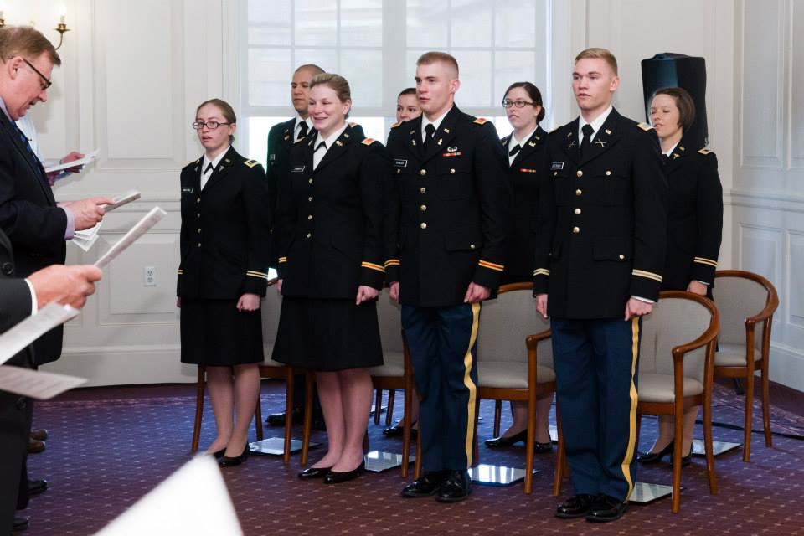

**Other Incentives:**

* **Leaders Training Course (LTC) Contracting Bonus**: $5000 bonus for students who contract after attending LTC. This Bonus is for cadets that contract after August 2008.
* **The Critical Language Incentive Pay (CLIP) program** is offering $100-$250 a month for Cadets willing to study one of the following languages: Arabic, Persian-Farsi, Persian-Dari, Chinese-Mandarin, Pashto, Urdu, Indonesian, Swahili, Hausa, and Korean, Japanese. The pay starts at $100 and increases as the language level of study increases. This program is for Cadets that contract after August 2008.
* **Student Loan Repayment Program (SLRP)** offers to repay federal student loans in return for at least 3 years of service.

**Cadet Responsibilities**

**Leaders of Character**

As an Army Cadet you have volunteered to adhere to higher standards of conduct and personal excellence as embodied in the Army Values, the Cadet Creed and the Soldier’s Creed. Your Leadership Development Process (LDP) will prepare you for the challenges you will face at LDAC and beyond. Should you violate any of the stated standards of conduct or fail to meet the stated scholarship retention standards you may be subject to administrative suspension or potential disenrollment proceedings. It is critical that you understand your obligations and begin to live the Warrior’s Ethos…“I Will Always Place the Mission First, I Will Never Accept Defeat, I will Never Quit and I Will Never Leave a Fallen Comrade” – BULLDOG PRIDE!

**CONTRACTED AND SCHOLARSHIP CADETS**

As a contracted Army ROTC Cadet, your continued scholarship benefits in the program rely on meeting the following standards:

**Academics:**

All Cadets must strive for academic excellence. You cannot become an Army officer unless you graduate. Your primary mission at Truman State University is to excel at your academic studies. The national Order of Merit List (OML) program allocates the largest percentage of points to GPA (40%) in determining whether you receive your desired component of service (Active Duty or Reserve Duty) and your desired branch (Aviation, Infantry etc.). Your grades come first! Probation and/or disenrollment from the program will result unless the following standards are met:

* Cumulative or term GPA over 2.0
* Make acceptable progress towards your degree IAW CC Form 104-R Planned Academic Program Worksheet in order to remain academically aligned
* Pass all classes with a D or higher (some academic departments require a C to pass)
* Maintain full-time student status throughout the term, not less than 12 credit hours
* Earn a grade of at least a “C” in all Military Science courses
* Have no misconduct or incidents with authorities that would discredit the program or the U.S. Army

**Participation / Attendance**:

Cadets must be present for the following events.

• Appearance and Grooming: Cadets are required to meet grooming standards outlined in CC Reg 670-1. These standards are located beginning on page 31 of this handbook.

• Height and Weight. Cadets must meet height and weight standards outlined on AR 600-9. These standards are located on page 44 of this handbook.

• Leadership Laboratories: Labs are held one day each week for approximately two hours.

• Field Training Exercises (FTXs): FTXs are two to three day exercises held on weekends and allow cadets the chance to practice their leadership ad tactical skills in a field environment. We generally hold one FTX per semester.

• Physical Readiness Training (PRT): Physical stamina is an essential component of leadership. Failure to maintain physical fitness, either by failing the APFT or the height and weight standards, will result in disenrollment. Cadets should expect to devote at least five hours per week to physical fitness. PT is held Monday, Wednesday and Friday every week by the battalion at 0600. Cadets must continuously pass the Army Physical Fitness Test (APFT) with a minimum score of 180 points total with 60 points in each event based on age and gender.

• Warrior Forge/ Leadership Development Assessment Course (LDAC): Cadets usually attend Warrior Forge between the junior and senior year and must successfully complete camp to become an Officer. The 31-day camp incorporates a wide range of subjects designed to develop and evaluate leadership ability. The challenges are rigorous and demanding, both mentally and physically. They test intelligence, common sense, ingenuity and stamina. These challenges provide a new perspective on a Cadet's ability to perform exacting tasks and to make difficult decisions under demanding conditions.

• Military Dining-Out: A military Dining-Out is a formal social event held each spring. The Dining-Out is a training event used to introduce cadets to military social functions.

• Veteran’s Day Ceremony: Cadets will participate in a special tribute to our fellow service men and women.

**NON CONTRACTED CADETS**

The Basic Course is open to any student on campus without stipulation or obligation. However those Basic Course Cadets interested in completing the ROTC program are welcome and encouraged to participate in any and all cadet activities. Non-eligible cadets will not progress to the Advanced Course and all cadets must contract not later than the second semester of their junior year.

**Cadet Mentorship Program**

TSU Army ROTC employs a peer mentorship program whose goals are to:

a. Promote academic excellence.

b. Support development of the knowledge, skills and attributes necessary for successful completion of academic and commissioning goals.

c. Model Army Values, professional ethics and expose cadets to the concept of the Warrior Ethos.

d. Encourage development of supportive relationships with other Cadets, Faculty, Cadre, and Staff.

e. Promote self-confidence by clarifying standards, expectations and providing routine feedback.

f. Develop leadership skills that enable Cadets to better citizens and future Army officers.

The mentorship program pairs MS IV (seniors) with underclassmen protégés to accomplish these goals. MS IVs meet initially with new cadets to provide an orientation based on the Cadet Checklist (TSU Form 2-R) and complete initial reviews of this Cadet Handbook, command policies and completing the Cadet Data Sheet (TSU Form 1-R). Seniors then meet monthly with underclassmen (typically 3-4 protégés per senior) and update Cadet data sheets on progress in Cadet training, academics status and physical fitness. Mentors meet informally with their protégés at PT, leadership labs and socially in the Cadet Lounge and other functions to routinely provide support and give pass along program information and provide answers to questions.

All Cadet Mentorship Program information can be found on the U: Drive at

U:\\_MS Student File Area\MENTORSHIP