PSYC 334 The Science of Health and Resilience Spring 2023
Dr. Fred Shaffer
We will communicate by email. Please check it regularly, including Spam and Trash filters. Our first quiz will be on Monday, January 17th. Plan to attend every class on time. Students arriving more than 5 minutes late may not take our daily quiz save for weather hazards.

OFFICE HOURS
I am fully vaccinated and masked. If you wish to see me in person, you must be masked without symptoms or recent COVID exposure. I have set up my office for our safety. Hours are M-F, 9:30-10:20 in Barnett 2401, and by appointment on Zoom.

YOU WILL NEED A PLAN B
Identify an alternative computer and internet source (Plan B) if our class goes online. You may be able to use your phone as a hot spot if your internet goes down.

CLASS DESCRIPTION
Format: Our class will be completely in-person and will feature lectures followed by a quiz or exam proctored from my desktop.
Academic integrity: You may not use any resource or confer with anyone during a quiz, exam, or Final. Your first violation of this policy will result in a score of 0 and referral to the Provost. Your second violation will earn a semester grade of F and Provost referral.
How to prepare: read assigned chapters and take a practice quiz. Proctored in-person assignments will require more in-depth study than taking them online using diverse resources (e.g., notes, text, classmates). Dust off your pre-pandemic study habits, expectations, and ethics.
COVID precautions: follow current Truman guidelines on masking and distancing.
If you have or suspect you have COVID: follow Truman’s testing and quarantine policies. Do NOT attend class. I will exempt your assignment.
If you miss class: review the chapter Lecture and Kahoot. Quizzes and exams may not be reopened or taken online when our class meets in person.

Contact
Email | fredricshaffer@gmail.com (place PSYC 334 in the subject line)
Hours | M-F 9:30-10:20 in BT 2401, and by appointment on Zoom
Support | ITS: 660-785-4544 Blackboard: 660-785-4026
My website | http://fshaffer.sites.truman.edu/
Fast Course Facts
Attendance | In-person
Quizzes | Thirty-eight 5-point objective question quizzes may not be rescheduled. Blackboard will silently drop your lowest quiz.
Exams | Four 50-question objective questions (50 points). They may not be rescheduled.
Extra Credit | 20 points from all sources (SONA and 10-question A Team with Heart Extra-Credit Exam).
Comprehensive Final | Required with 100 objective questions (100 points).
Text | Biofeedback Tutor and Biofeedback and Mindfulness in Everyday Life.
Resources
Week in the ‘ville | Emailed to you
Exams and Quizzes | Assignments
Practice Tests | Assignments
Syllabus, Exam Guides, Podcasts, Kahoots | Course Documents
Internet Videos | External Links
Truman Policies and  Resources | Syllabus Appendix
Winning Study Strategies
Read the entire chapter and take a practice quiz before each class. Practice quizzes and tests don’t count toward your grade, and you may take them as often as you want
Take notes on each chapter and then type up and review your notes
Review missed learning objectives, Guides, and Kahoots for exams, and Final

CATALOG DESCRIPTION

The Science of Health and Resilience explores the two-way relationship between the mind and body. Students review the philosophy of science and the application of the scientific method in psychology, and the science and technology underlying biofeedback and neurofeedback for health and improved performance. This course covers topics relevant to student wellbeing, including relaxation and stress management, and the entire BCIA Biofeedback blueprint. Prerequisites: Grade of C, or better, in PSYC 166 - General Psychology and PSYC 266 - Experimental Psychology.
MY EXPECTATIONS
I expect you to succeed. Listen to every podcast and study 9 hours per week (135 hours per semester) for an A. College is a marathon that rewards discipline and consistent effort. We will strive together to create an environment that celebrates diversity, mutual respect, scholarship, and critical thinking.

COMPLIANCE
Our class follows University policies concerning Academic Integrity, ADA Accommodations, Attendance, and Sexual Harassment. If you have an accommodation letter, please contact the Student Access Office (x4478) and me as soon as possible. See Appendix.

TEXT
This class requires the multimedia tutorial Biofeedback Tutor and Biofeedback and Mindfulness in Everyday Life. You will need them for the first day of class.
THE SCIENCE OF HEALTH AND RESILIENCE IS A LIBERAL ARTS AND SCIENCE COURSE
Following Phi Beta Kappa’s description: “in acquiring a liberal education, the undergraduate will study primarily subjects which illuminate the human condition, subjects which explore aspects of taste and feeling, of the reasoning process, of the physical and moral worlds, of individual and group responsibility, of the meaning of life as a whole."

KAIZEN
Our course utilizes kaizen (change + good) or continuous improvement. I evaluate previous question performance and rewrite/replace poorly performing items in building each semester’s quizzes and exams. This review also helps me target learning objectives that require better explanation.

COURSE OUTCOMES AND HOW WE WILL ACHIEVE THEM
Students who successfully complete this course will understand the philosophy of science and the application of the scientific method in psychology, ethics, electronics and biomedical instrumentation, anatomy and physiology, biofeedback’s clinical and
performance applications and their efficacy, and important wellness concepts and skills.
You will find chapter-specific learning objectives in our exam guides (Course Documents).

BOTTOM LINE

I expect you to attend every class session on time, review assigned textbook chapters, and complete quizzes, exams, and our Final.
GRADES
Your grade will be based on 490 points:
38 objective quizzes (5 questions) = 5 points = 190 points
4 exams (50 objective questions) = 50 points = 200 points
comprehensive final (100 objective questions) = 100 points
To protect our question pool, you may only review quizzes and unit exams in class immediately after submitting your answers. You may not take notes from this review. Last, you may not review answers on your Final.
The grading scale is A = 90%, B = 80%, C = 70%, and D = 60%. I will round 89.5% to an A, while 89.4% will remain a B. Work hard and do extra credit to ensure the grade you want. There will be no opportunities to do extra work to raise your grade after the Final. Practice exams and quizzes do not count toward your grade.

MISSED QUIZZES, UNIT EXAMS, AND FINAL
You may not reschedule quizzes, exams, or our Final.

UNIVERSITY-APPROVED EVENTS
I will exempt up to 6 quizzes and 1 exam for absences for university-sponsored activities if you contact me in advance with documentation. An exemption means that the assignment will not count for or against you.

HEALTH CRISES
I will exempt up to 6 quizzes and 1 exam for absences due to quarantine, medical appointments, and hospitalizations if you contact me in advance or immediately after a missed class.

MISSED FINAL
If you don’t take your Final during its scheduled period due to an excused reason, you may take it during one of my remaining Finals. If you miss your Final for an unexcused reason, I will assess a penalty of 25 points per day.

QUIZ OR EXAM QUESTION APPEAL
Our textbook is authoritative, so always choose its authors’ perspective if it disagrees with a practice question.

Review the relevant section of our textbook before challenging an answer and include the page number in your appeal. You must email me your concerns about a quiz or exam within 24 hours of its completion. After that time, I will not review your grade on that assignment.

EXTRA CREDIT
You may earn a maximum of 20 points from a combination of participation in research on the SONA system and a 10-question extra-credit exam over A Healthy Heart. I will enter SONA credit in a single column (SONA) by exam 4.

Nearly all classes in the Psychology department utilize an online system called SONA for participating in research being conducted by our students and faculty members. Early in the semester, you will receive an email from SONA informing you of your unique UserID and Password, as well as instructions and rules for using the system. You will use SONA to identify research opportunities in the department and then to volunteer for them. Credits earned in SONA can be applied as extra credit points in your PSYC classes. Note that all research participation is voluntary, all studies must pass ethical review before being posted on SONA, and you may take the extra-credit exam instead if you’d rather not participate in research. Be sure to read each study’s description before signing up, as some research is on topics that may make you uncomfortable. Up to 20 credits earned in SONA for our class can be used as extra credit.

BIOFEEDBACK TUTOR

Please click on this sentence to open Biofeedback Tutor in your browser. Once you have opened it, bookmark the page.
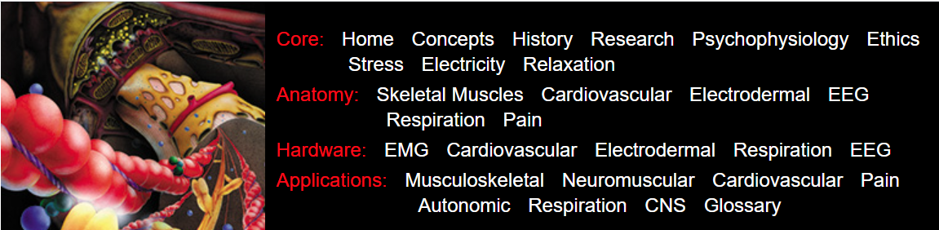
Username and Password
Please copy and paste the username and password we provided into the login box.
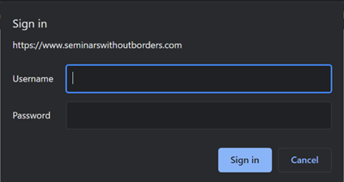

How to Take ClassMarker Exams
Please log in using the following link: https://www.classmarker.com. Use the same username and password to log into Biofeedback Tutor. Please copy and paste these credentials into the login box. Do not click on the orange Register Free button as we have already enrolled you. ClassMarker exams do not count toward your grade.

What Do We Have To Study?
We have hidden advanced content using Read More buttons. I will not test you over this material. However, if you want to learn more, click once to see it and again to hide it.

CALENDAR
Spring 2023 Calendar for PSYC 334
Biofeedback Tutor units are followed by Khazan chapters
For Biofeedback Tutor: A = Anatomy, H = Hardware, Aps = Applications
Assignments are due during class time and may not be extended or rescheduled
Week 1  Jan 17 Concepts; Ch 1  Biofeedback (Q1)  Jan 19 History; Lehrer (Q2)  Jan 21 Psychophysiology;  Ch 7 Foundations (Q3) | Week 7  Feb 28 Ch 10 Compassion (Q17)  Mar 1 A: Cardiovascular; Ch 5  Temperature (Q18)  Mar 3 A: Cardiovascular; Ch 3 HRV  (Q19) | Week 13  April 10 Exam 3  April 11A: EEG(Q31)  April 13 H: EEG (Q32)
Week 2  Jan 24 Martin Luther King, Jr.  Jan 26 Stress; Ch 12 Stress (Q4)  Jan 28 Electricity (Q5) | Week 8  Mar 6 Exam 2  Mar 8 H: Cardiovascular (Q20)  Mar 10 Aps: Cardiovascular (Q21) | Week 14  April 17 Term Break  April 19 Aps: CNS (Q33)  April 21 Ch 14 Anger (Q34)
Week 3  Jan 31 H: EMG (Q6)  Feb 1 H: EMG (Q7)  Feb 3 Exam 1 Ch 1-4 | Week 9  Mar 13-17 Spring Break | Week 15  April 24 Ch 17 Sadness (Q35)  April 26 Ch 18 Shame (Q36)  April 28 Moss address (Q37)
Week 4  Feb 6 Ethics; Moss (Q8)  Feb 8 A: Skeletal (Q9)  Feb 10 Aps: Musculoskeletal;  Ch 4 Muscle Health(Q10) | Week 10  Mar 20 Aps: Cardiovascular (Q22)  Mar 22 A: Respiration (Q23)  Mar 24 H: Respiration (Q24 | Week 16  May 1 Khazan address (Q38)  May 3 Moss Ethics (Q39)  May 5 Exam 4; A Team with Heart  Extra-Credit Exam
Week 5  Feb 13 Aps: Neuromuscular  (Q11)  Feb 15 Relaxation (Q12)  Feb 17 Ch 8 Mindfulness  Meditation (Q13) | Week 11  Mar 27 Aps: Respiration; Ch 2  Breathing (Q25)  Mar 29 Aps: Respiration (Good  Breathing); Ch 13 Anxiety (Q26)  Mar 31 A: Electrodermal (Q27) | Week 17  May 8 (Mon) Final 11:30-1:20  May 10 Reading Day
Week 6  Feb 20 A: Pain (Q14)  Feb 22 Aps: Pain; Ch 16 Pain  (Q15)  Feb 24 Aps: Pain (Q16) | Week 12  April 3 H: Electrodermal; Ch 6  Skin Conductance (Q28)  April 5 Zombie Apocalypse; Ch 11  Sleep (Q29)  April 6 Ch 15 Interpersonal  Communication (Q30)

APPENDIX: UNIVERSITY POLICIES AND RESOURCES

Disability Services

To obtain disability-related academic accommodations, students with documented disabilities must contact the course instructor and the Office of Student Access and Disability Services (OSA) as soon as possible. Truman complies with ADA requirements. For additional information, refer to the Office of Student Access and Disability Services website at http://disabilityservices.truman.edu/
You may also contact OSA by phone at (660) 785-4478 or email studentaccess@truman.edu

Emergency Procedures

In each classroom on campus, there is a poster of emergency procedures explaining best practices in the event of an active shooter/hostile intruder, fire, severe weather, bomb threat, power outage, and medical emergency. This poster is also available as a PDF at this link: http://police.truman.edu/files/2015/12/Emergency-Procedures.pdf.
Students should be aware of the classroom environment and note the exits for the room and building. For more detailed information about emergency procedures, please consult the Emergency Guide for Academic Buildings, available at the QR code shown or at the following link: http://police.truman.edu/emergency-procedures/academic-buildings/
This six-minute video provides some basic information on how to react in the event there is an active shooter in your location: http://police.truman.edu/emergency-procedures/active-shooter/active-shooter-preparedness-video/.
Truman students, faculty, and staff can sign up for the TruAlert emergency text messaging service via TruView. TruAlert sends a text message to all enrolled cell phones in the event of an emergency at the University. To register, sign in to TruView and click on the “Truman” tab. Click on the registration link in the lower right of the page under the “Update and View My Personal Information” channel on the “Update Emergency Text Messaging Information” link. During a campus emergency, information will also be posted on the TruAlert website http://trualert.truman.edu/.

Discrimination and Title IX

Truman State University, in compliance with applicable laws and recognizing its deeper commitment to equity, diversity and inclusion which enhances accessibility and promotes excellence in all aspects of the Truman Experience, does not discriminate on the basis of age, color, disability, national origin, race, religion, retaliation, sex (including pregnancy), sexual orientation, or protected veteran status in its programs and activities, including employment, admissions, and educational programs and activities. Faculty and staff are considered “mandated reporters” and therefore are required to report potential violations of the University’s Anti-Discrimination Policies to the Institutional Compliance Officer.
Title IX prohibits sex harassment, sexual assault, intimate partner violence, stalking and retaliation. Truman State University encourages individuals who believe they may have been impacted by sexual or gender-based discrimination to consult with the Title IX Coordinator who is available to speak in depth about the resources and options. Faculty and staff are considered “mandated reporters” and therefore are required to report potential incidents of sexual misconduct that they become aware of to the Title IX Coordinator.
For more information on discrimination or Title IX, or to file a complaint contact:
Institutional Compliance Officer, Title IX, and Section 504 Coordinator
Office of Institutional Compliance
Violette Hall, Room 1308
100 E. Normal Ave
Kirksville, MO 63501
Phone: (660) 785-4354
titleix@truman.edu
The institution’s complaint procedure can be viewed at http://titleix.truman.edu/files/2015/08/University-Complaint-Reporting-Resolution-Procedure.pdf and the complaint form is accessible at http://titleix.truman.edu/make-a-report/.

Statement regarding academic integrity/plagiarism policy in accordance with the University policy and procedures, for example:
“ACADEMIC HONESTY – Personal and scholarly integrity are expected of everyone in the class. Failure to live up to those responsibilities, risks earning a failing grade on the assignment/examination, a failing grade for the course, and/or in serious cases expulsion for the academic program or University. The University policy on academic dishonesty as published in the Student Conduct Code and General/Graduate Catalog applies (http://catalog.truman.edu/content.php?catoid=15&navoid=801#Academic_Dishonesty)

FERPA

Education records are protected by the Family Education Right to Privacy Act (FERPA). As a result, course grades, assignments, advising records, etc., cannot be released to third parties without your permission. There are, however, several exceptions about which you should be aware. For example, education records can be disclosed to employees or offices at Truman who have an “educational need to know”. These employees and offices may include your academic advisor, the Institutional Compliance Officer, the Registrar’s Office, or Student Affairs, depending on the type of information. For more information about FERPA, see http://www.truman.edu/registrar/ferpa/.

Statement on Disruptive Behavior

“Behavior that persistently or flagrantly interferes with classroom activities is considered disruptive behavior and may be subject to disciplinary action. Such behavior inhibits other students’ ability to learn and an instructor’s ability to teach.
A student responsible for disruptive behavior may be asked to leave class pending discussion and resolution of the problem…” and may be reported to the Office of Citizenship and Community Standards. (Quotation from Washington State University).

ABOUT DR. SHAFFER

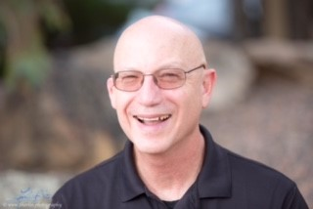
I am a Professor of Psychology and have proudly taught at Truman since 1975. I served two terms as Psychology Department Convener and have supervised the Center for Applied Psychophysiology since 1976.
I earned a BA in Psychology and Political Science with a minor in Philosophy/ Religion from Claremont Men’s College in 1971.
I completed a MS in Clinical Psychology in 1973 and a PhD in Social-Personality Psychology in 1975 from Oklahoma State University.
In 2008, I received the Walker and Doris Allen Fellowship for Faculty Excellence at Truman State University.
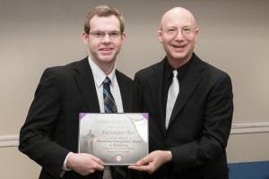
In 2013, I received the Outstanding Research Mentor of the Year award at Truman for my supervision of the Center for Applied Psychophysiology since 1976. (Former Assistant Director Christopher Zerr is shown with his Order of Omega Leadership Award.)
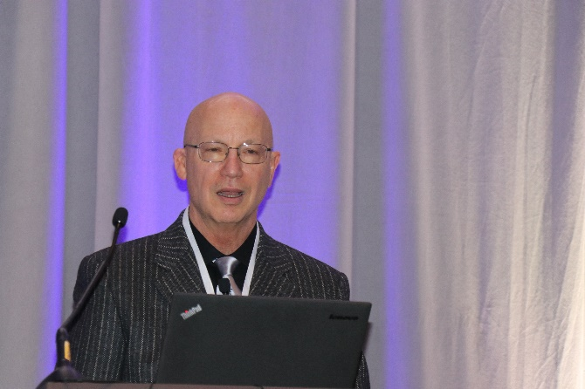
In 2019, I received AAPB’s Distinguished Scientist Award, was chosen the Association for Applied Psychophysiology and Biofeedback (AAPB) President-Elect and delivered an address that celebrated the contributions of our biofeedback and neurofeedback community. I will serve as AAPB President for 2 years.
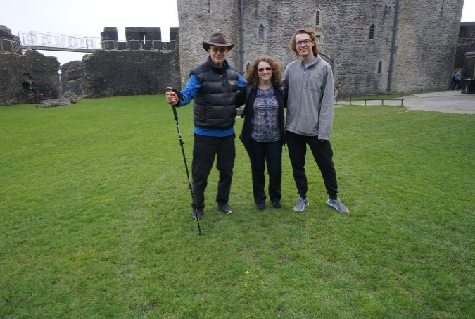
April 2019, I attended the Biofeedback Federation of Europe conference in Cardiff, Wales. Above are Dr. Inna Khazan and Nick Gravett (Truman alumnus) at Caerphilly Castle, the largest in Wales. We stormed it.
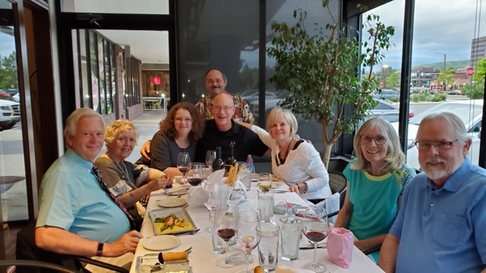

In 2020, the Biofeedback Certification International Alliance (BCIA) created a perpetual Heart Rate Variability Biofeedback scholarship that waives certification fees in my name. This generous gift gives priority to Military applicants. In the BCIA Board picture above, Dr. Inna Khazan is to my left, Dr. David Hagedorn is behind me, and Judy Crawford (Executive Director) is to my right. My decades-long teaching and writing partner, Dr. Don Moss, is front left, and Dr. Randy Lyle (our Board Chair) is front right. We were graced by their late wives, Nancy and Carla. Our BCIA family will greatly miss them.
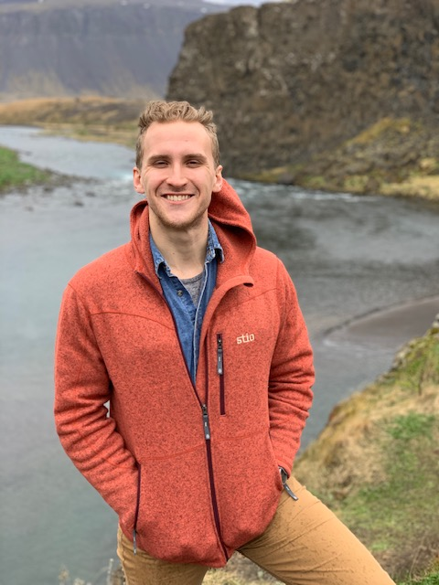
Skeiða-og Gnúpverjahreppur
May 2019, I toured Reykjavík, Iceland with Zachary Meehan following his graduation from the University of Northern Iowa with a Master’s in Clinical Science. He is currently a Clinical Doctoral student at the University of Delaware.
Mýrdalshreppur
Reynisfjara Beach

I regularly visited Golden, Colorado, for hiking, great food, and professional writing several times a year. I will resume my visits when it is safe.

